**Project Plan**

|  |  |
| --- | --- |
| **Team 2B** |  |

# **Brief problem statement**

Investing Corp. is a funding company committed to improving the life in the communities national-wide by providing collaborative mechanisms on top of information technology solutions. To this end the company proposes a tool-sharing web-application that allow the members within the communities to exchange their tools (and potentially other kind of items). The product’s name is “ToolShare” and its implementation should follow usability-guidelines in order to provide a superior user-experience.

# **Team Members**

Team members & their functions:

|  |  |
| --- | --- |
| **Role** | **Name** |
| Team Leader & Coordinator | Kate Karauda |
| Requirements Coordinator | Leonardo Matos |
| Development Coordinator | Harold Valdivia Garcia |
| Test Coordinator | Omeya Jadhav & Dipti Menda |

# **Team Communication**Our team has one regular meeting every week on Fridays at 5:00PM at the SE Department in the Student-Rooms. Alternatively, if an unexpected event prevents us from having regular meeting, this will be re-scheduled to Tuesday at 6:30PM.

As channel of communication, our team will be using RIT-emails. For editing documents collaboratively, we will be using Google-Drive. Additionally, our project will be handled with Microsoft-Project.

# **Development Environment**

The application’s back-end will be written mainly in Python3 on top of Django (Web-Framework) and the team will use PyCharm for its development. The project management will be handled with “Microsoft Project” and the modeling with StarUML.

# **Milestone Schedule**

|  |  |  |  |  |  |
| --- | --- | --- | --- | --- | --- |
| Milestone | Duration | Start | Finish | Release | Deliverable |
| Django - Tutorial Parts 1-4 | 7 days | Fri 8/29/14 | Mon 9/8/14 | R1 | No |
| Project Plan & Requirements | 5 days | Mon 9/8/14 | Fri 9/12/14 | R1 | Yes |
| Setup SVN | 5 days | Mon 9/1/14 | Fri 9/5/14 | R1 | No |
| Homework 1 | 10 days | Mon 9/1/14 | Fri 9/12/14 |  | No |
| Design Document & Stable Prototype | 10 days | Mon 9/15/14 | Fri 9/26/14 | R1 | Yes |
| Homework 2 | 5 days | Mon 9/22/14 | Fri 9/26/14 |  | No |
| Homework 3 | 5 days | Mon 9/29/14 | Fri 10/3/14 |  | No |
| Release 1 - Presentation | 5 days | Mon 9/29/14 | Fri 10/3/14 | R1 | Yes |
| Release 2 Plan | 5 days | Mon 10/13/14 | Fri 10/17/14 | R2 | Yes |
| Beta Release | 5 days | Mon 10/6/14 | Fri 10/10/14 | R2 | Yes |
| Homework 4 | 5 days | Mon 10/20/14 | Fri 10/24/14 |  | No |
| Test Plan | 5 days | Mon 10/20/14 | Fri 10/24/14 | R2 | Yes |
| Homework 5 | 5 days | Mon 11/24/14 | Fri 11/28/14 |  | No |
| Cross-Team Testing | 5 days | Mon 12/1/14 | Fri 12/5/14 | R2 | Yes |
| Release 2 - Presentation | 5 days | Mon 12/8/14 | Fri 12/12/14 | R2 | Yes |

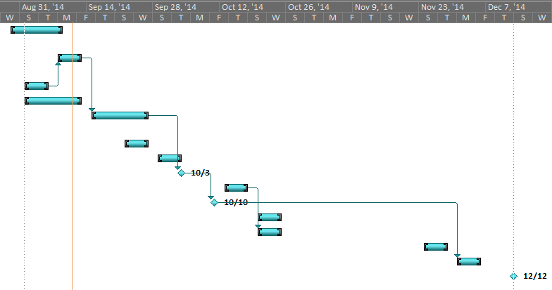

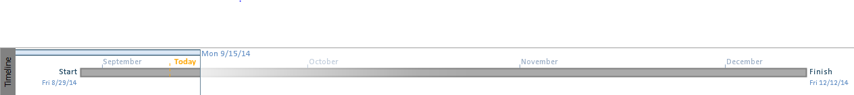

**List of Use-Cases for Release 1:**

* UC-01 Register user
* UC-02 Change personal information
* UC-03 Change user preferences
* UC-04 Create Community Shed
* UC-05 Register tools
* UC-17 Log-in